Green Market

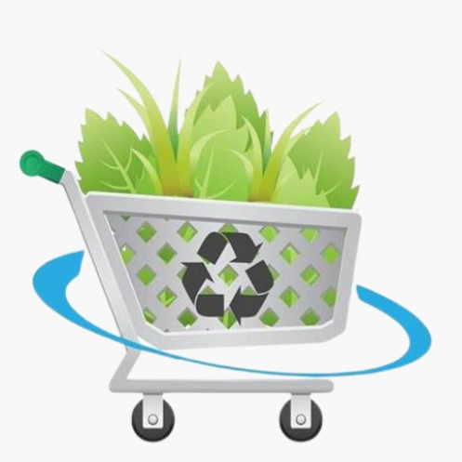

**FUNDAMENTALS OF INNOVATION AND ENTREPRENEURSHIP**

Section 22E

Dr. **Jenna Abdalla**

**Sultan Juma Alshamsi U20200009**

**Mahaz Ishtiaq Khan U22200217**

**Shahad Alhosani U20100004**

**Abdulla Almuhairy U21106429**

**Diaa Ibrahim Nasr U20100783**



**Table of Content**

Introduction 3

Problem 4

Empathy 5

Define 6

Solution 7

Ideate 8

Prototype 10

landing Page 10

Registration page 11

Login page 12

Recycle products page 13

Add product page 14

Check out page 15

User profile page 16

Testing 17

STEP 1: ADVERT 17

STEPS 2 and 3: MARKETING CHANNEL AND FEEDBACK 17

STEP 4: BULLS EYE 18

References 19

# Introduction

“Nearly one in ten people around the world go to bed hungry each night”[1], world hunger, a problem that could be mitigated if we stop wasting food according to the U.N. Food and Agriculture Organization, if we stopped wasting all that food, we’d save enough to feed 2 billion people. That’s more than twice the number of undernourished people across the globe.[2] Even though world hunger is not only caused by wasting food, wasting food is one of the main causes, also food loss and wastage affects 40 percent or more of the total amount of food produced, says a UN agency official[3]. So, when is it time to stop? When is it time to act upon a problem that the world suffers from?

In this document, we will be discussing food waste, and presents a website that can help minimize world hunger, why you might ask? for many reasons, some of which are: According to Forbes, 71% of businesses have a website in 2023 and 28% of business is conducted online [4] from that we can deduce that there is a trend across the globe for business which is the use of websites, and that also means that users are accommodated to the use of websites, that includes making purchases online.

# Problem

Food waste is a lesser-known problem in our current age, even though the problems it creates are huge. Lots of food is wasted from different sources such as restaurants, residential buildings and even farms. What people don’t know about food waste is that not only is lots of energy and money that is required to grow and harvest food lost, but food waste also produces methane, a very harmful gas to the environment.

According to UAE Food Banks[5]:

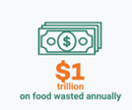 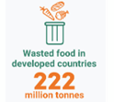 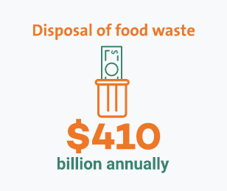

Food is wasted nearly everywhere, but the biggest contributors in the UAE are hotels and restaurants, according to the Living Business. It is very important that a solution is quickly found, so as to not intensify the problem.[6]

## Empathy

We discussed the topic of food waste with different professionals in the field, asking them few questions such as:

* When did you learn about the problem?
* Does it affect your work?
* What solutions could be made?

**Muhanad; Employee in the university cafeteria responded:**

Although food waste in the UAE is more than other countries, here in the university they started converting food waste into fertilizer for the greenery. This process started a few months ago and is a relatively new technique here in the University of Sharjah.

**Saif; Employee in food waste management in the university responded:**

Food waste management is a difficult process, as unexpected problems appear and also the cost of processing food waste is expensive. The fertilizer made here in the university is not exported to other companies, but it is only used in university plants and greenery.

**Saeed Mousa; Employee in Dubai Municipality responded:**

Majority of food waste ends up in landfills and emits methane, a toxic greenhouse gas which negatively impacts the environment by contributing to global warming and climate change. Not only that but it also imposes risk on human health on the long term. Being exposed to large concentrations of methane can lead to less oxygen availability and a range of symptoms may be experienced such as: (Rapid breathing, increased heart rate, decreased alertness etc.…).

Solutions that he proposed for food waste are:

* Soil amendment (compost, fertilizers)
* Biofuel
* Animal feed
* Biochar

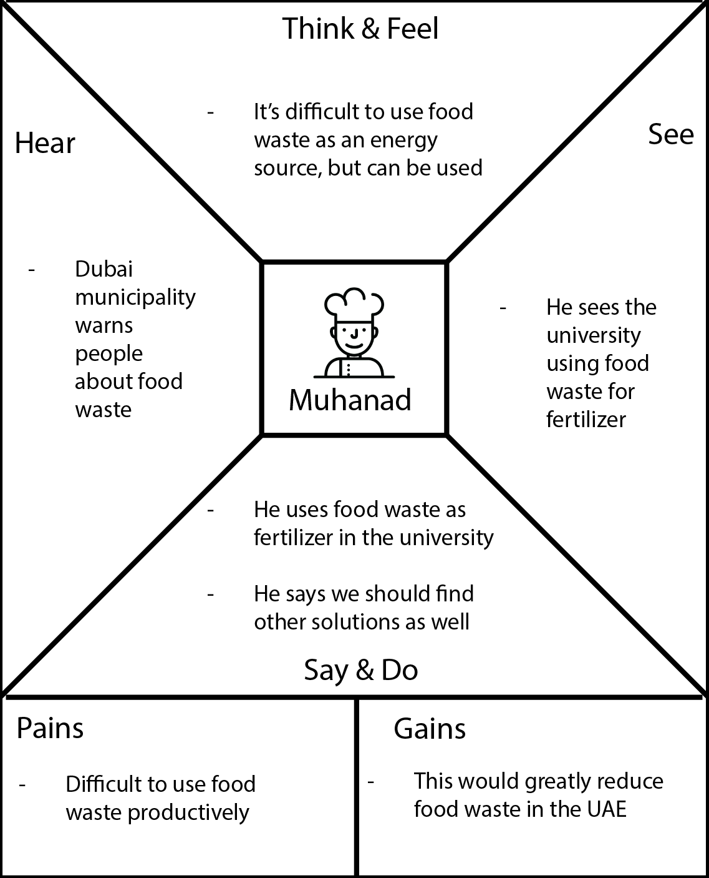

## Define

**Muhanad**

|  |  |
| --- | --- |
| Needs | Insight |
| Saving money | Best use for food waste is to convert to fertilizer |
| Reducing food waste in restaurants | Using food waste as fertilizer in restaurants and cafeterias |

**Saif**

|  |  |
| --- | --- |
| Needs | Insight |
| Other ways to use food waste | Could be used as biofuel or animal feed |
| Cost effective solutions for food waste | Fertilizer is a cheap solution |

**Saeed Mousa**

|  |  |
| --- | --- |
| Needs | Insight |
| Getting rid of waste to reduce methane | Reducing food waste in the UAE |
| Other ways to use food waste | Could be used for animal feed, biochar, or biofuel |

# Solution

Our proposed solution entails the creation of an innovative digital platform known as "Green Market Sustainability," dedicated to efficiently redistributing surplus or expired food items. By leveraging cutting-edge technology, seamless logistics, and collaborative partnerships with key stakeholders, Green Market Sustainability aims to tackle food waste while advancing sustainability efforts.

Digital Hub:

* At the heart of the initiative lies a user-friendly website, acting as the primary interface for Green Market Sustainability.
* Individuals, restaurants, and retailers can easily log in to input details of their surplus or expired food inventory, including type, quantity, expiry date, and minimum weight requirements.

Strategic Matchmaking:

* + Registered companies specializing in sustainable practices, such as agriculture, eco-friendly fertilizers, or biomass conversion, are seamlessly integrated into the platform.
  + Upon receiving information about surplus food items, Green Market Sustainability matches them with suitable companies based on their specific needs and capacities, fostering efficient collaborations.

Efficient Delivery Solutions:

* + Through strategic partnerships with delivery companies, surplus food is swiftly transported from the end user to designated recipients.
  + Delivery routes are meticulously optimized to minimize carbon footprint and maximize operational efficiency, ensuring a sustainable approach to logistics.

Charitable Contributions:

* + In addition to selling surplus food items, users have the option to donate them to charitable organizations or food banks.
  + Green Market Sustainability streamlines the donation process, connecting donors with appropriate recipients and ensuring the proper handling and distribution of donated food items.

Sustainable Impact:

Reduction of Food Waste:

* + By facilitating the redistribution of surplus or expired food, Green Market Sustainability significantly curbs food waste at individual, commercial, and community levels.

Resource Optimization:

* + Surplus food items are redirected towards productive avenues such as agriculture, sustainable fertilizer production, or biomass conversion, maximizing resource utilization and minimizing environmental impact.

Social and Environmental Responsibility:

* + The option to donate surplus food items fosters a culture of social responsibility and community engagement, promoting solidarity and support for those in need while reducing the environmental footprint of food waste.

## Ideate

Generating ideas: In this part, we apply the How Might We (HWE) technique to consider how wemight address some of the issues that the people who were interviewed were experiencing. We then makecreative decisions based on these responses that serve the needs of the consumer.

**MUHANAD’S:**

|  |  |
| --- | --- |
| **HMW** | **ANSWER** |
| How can we foster collaboration between universities and other sectors to expand food waste conversion initiatives? | By creating platforms for knowledge exchange and incentivizing partnerships, we can accelerate the adoption of food waste conversion techniques. |
| How can we overcome logistical challenges to ensure the sustainability of food waste conversion projects? | By creating a helpful website like Green Market Sustainability, we can overcome logistical challenges and ensure the success of food waste conversion projects through scalable frameworks and strategic partnerships. |

|  |  |
| --- | --- |
| **HMW** | **ANSWER** |
| How can we encourage companies to invest in food waste-derived fertilizers beyond their facilities? | Government subsidies or tax incentives could promote wider adoption of food waste-derived fertilizers among companies, leveraging platforms like Green Market Sustainability for distribution. |
| How can we optimize food waste management processes to reduce costs? | Integrating innovative technologies and best practices, as promoted on our Green Market Sustainability platform, can streamline processes and enhance the economic viability of food waste management. |

**SAIF’S:**

|  |  |
| --- | --- |
| **HMW** | **ANSWER** |
| How can we raise awareness about the environmental and health risks of food waste, particularly methane emissions? | Leveraging digital platforms like our Green Market Sustainability website and educational campaigns can effectively communicate the importance of proper food waste management. |
| How can we integrate alternative solutions like soil amendment and biofuel production into existing waste management infrastructure? | Collaborating with stakeholders and developing comprehensive strategies, as facilitated by our Green Market Sustainability platform, can incorporate alternative solutions and improve overall waste management efficiency. |

**SAEED MOUSA’S:**

## Prototype

### landing Page

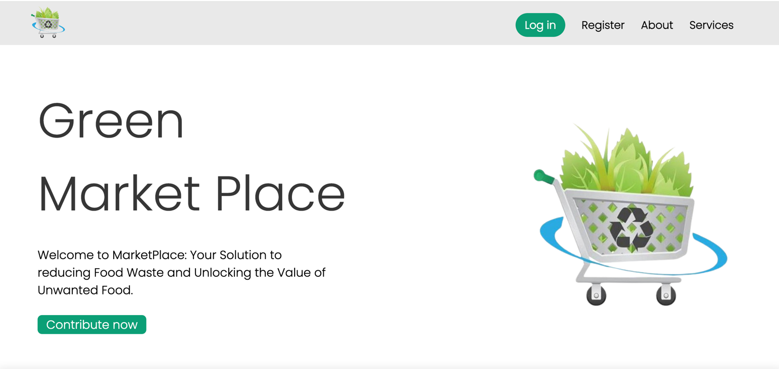

On the landing page, users will be greeted with a welcoming message and a brief introduction to the web application, outlining its purpose and goals. The navigation bar will provide users with options to choose from, including login, registration, an "about" section, and access to various services offered by the web application.



On the landing page the user could watch a brief video about the importance of environment sustainability and some practices and strategies we follow. Moreover, on this topic [Click Here](https://www.youtube.com/watch?v=n_kf7bpOk00&t=73s)

### Registration page

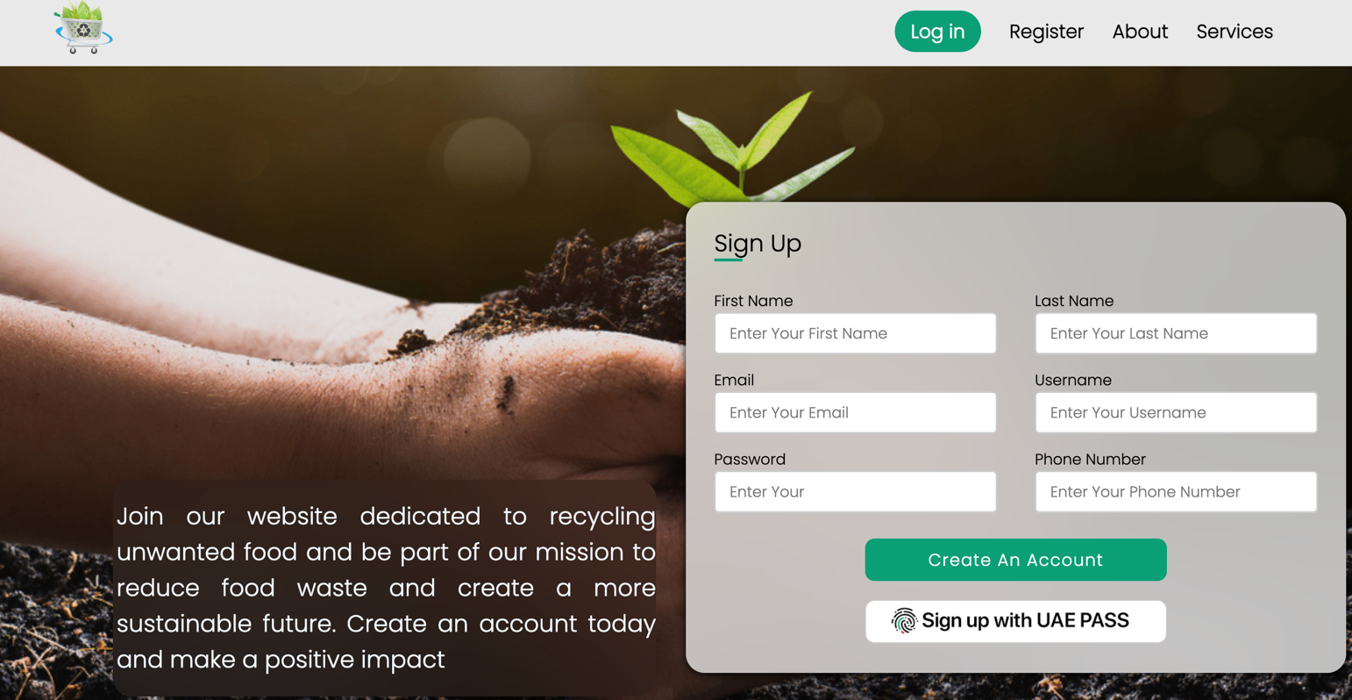

The initial image represents the registration page, where users must complete registration in order to access the web application. They are required to provide their first and last names, email address, a username, a password, and phone numbers, or can sign up with the UAE pass.

### Login page

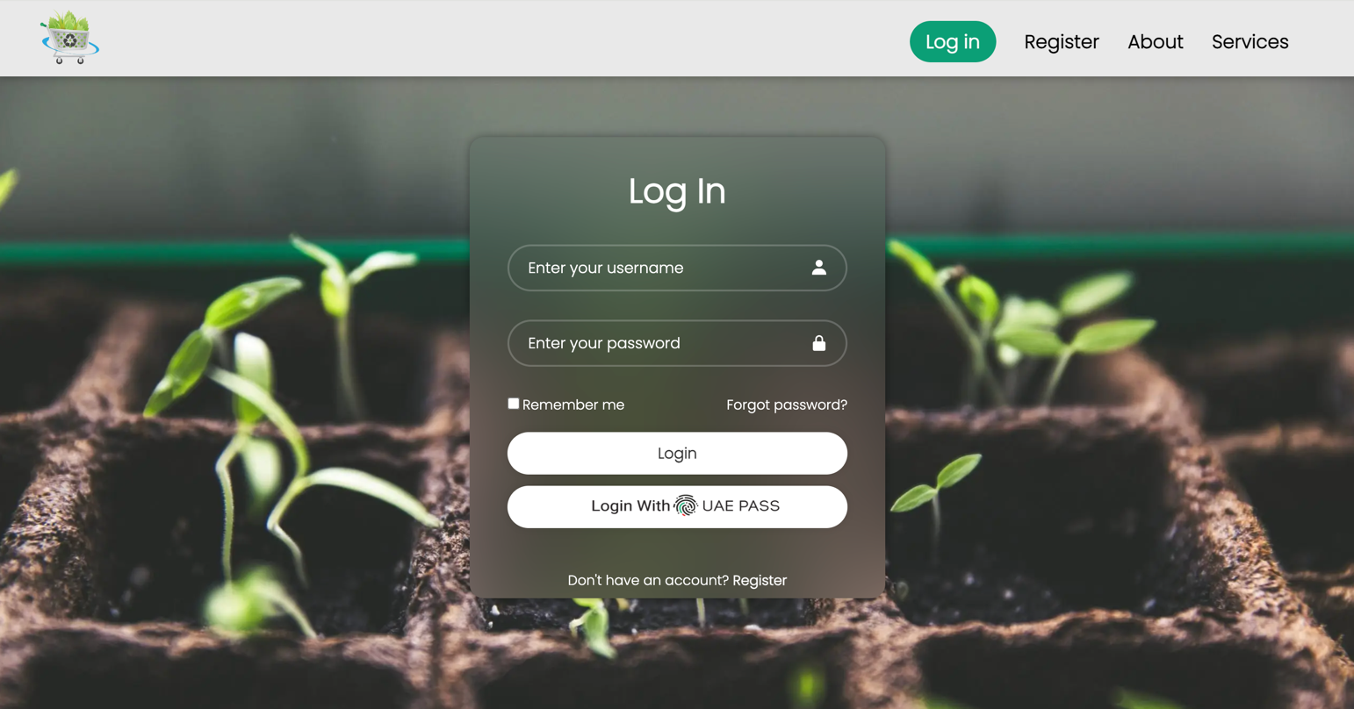

The login page provides users with the choice to log in using either their email address or phone number or logging in using the UAE pass if he/she used it to register.

### Recycle products page

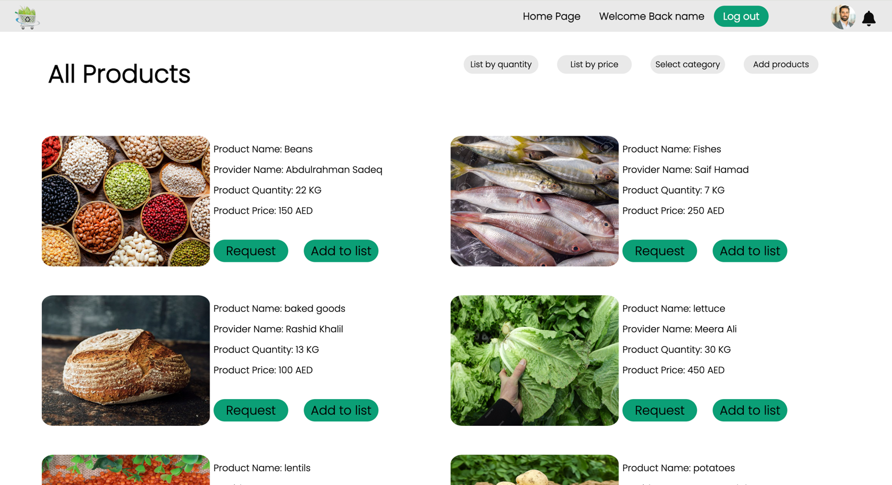

On the recycled products page, registered and logged-in users can explore a wide range of products. They are presented with two primary options: they can either purchase products or contribute by adding their own items to the listings for others to access. Users also have the capability to filter items based on price, category, or quantity, enabling them to easily find the products that match their preferences and needs.

### Add product page

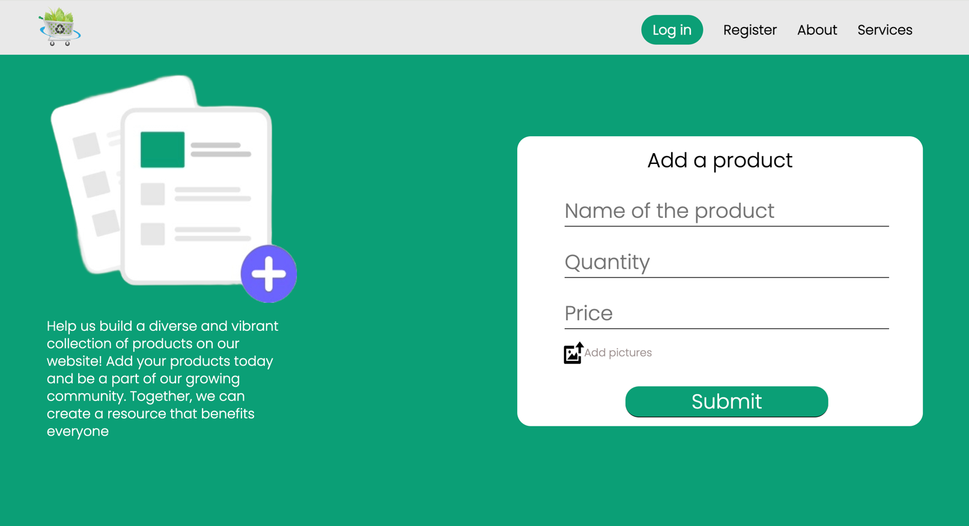

On this page, users can actively engage with the Green Market web application by contributing to our community. Users have the option to add a product to our platform, allowing them to provide essential details such as the product's name, quantity, and price. Additionally, they can enhance their product listing by including pictures if available, thereby enriching the experience for other users in our community.

### Check out page

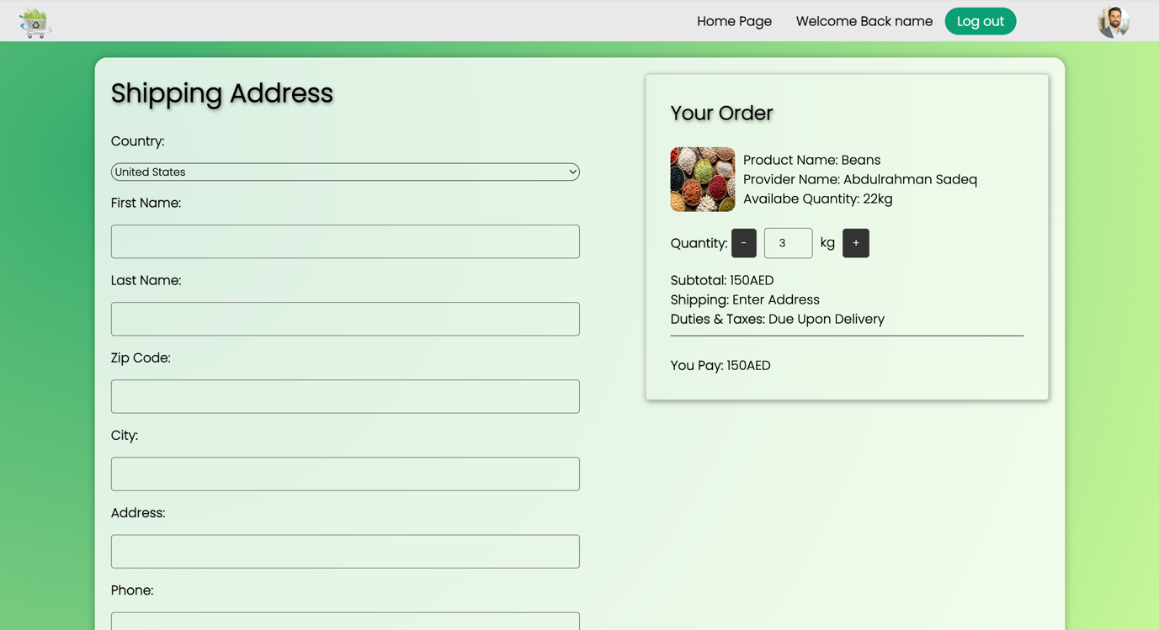

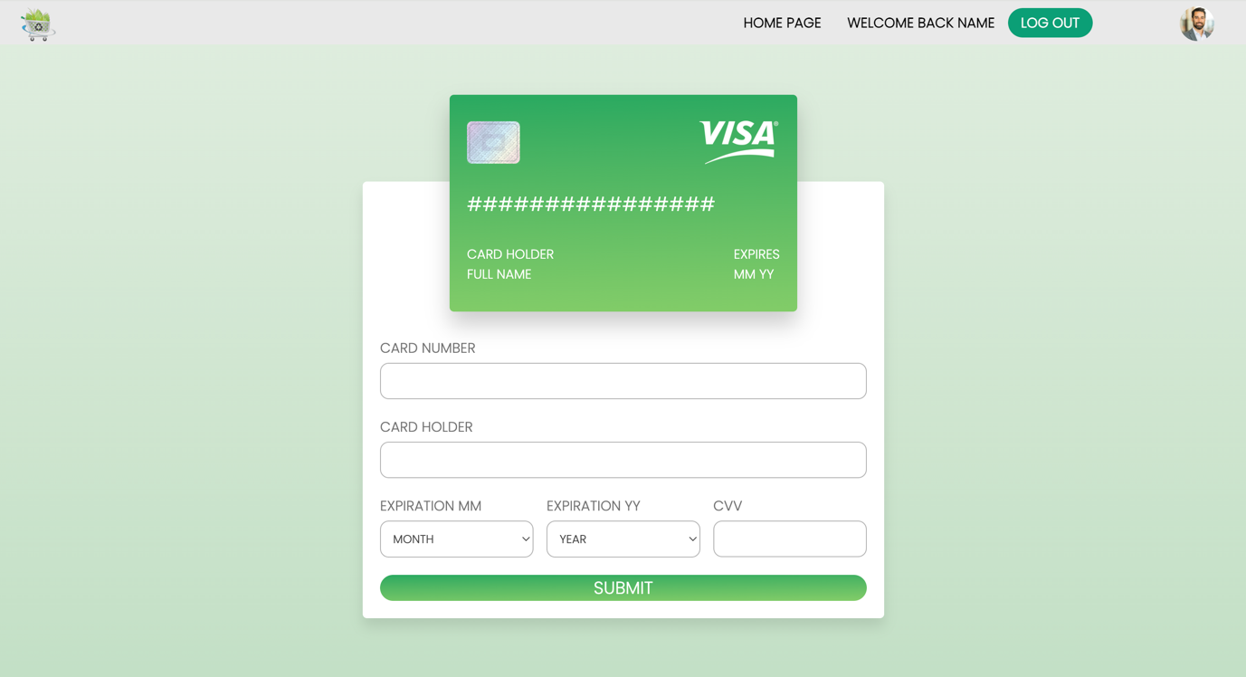

On the checkout page, after a user has added products to their cart, they will proceed to complete the purchase process. This involves selecting a preferred payment method from options such as Mastercard, Visa, or Cash on Delivery. The page will display the number of products in the checkout process and any associated shipping fees. Once the user has chosen their preferred payment method, they can click the confirmation button. This action will trigger the generation of a receipt, which will be sent to them, confirming their order and payment details.

### User profile page

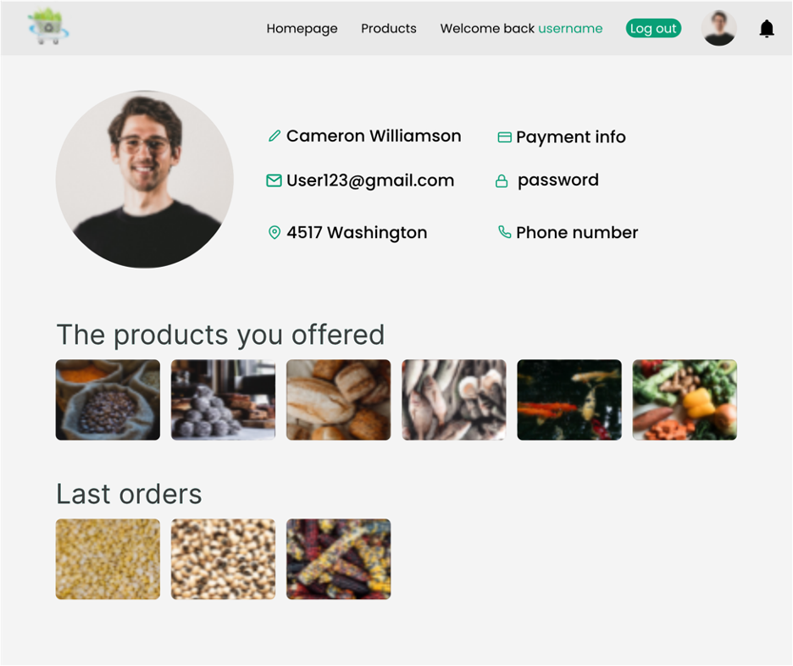

On the user profile page, all of the user's information will be readily accessible for their convenience. Users will have the capability to review and modify the details they provided during the registration phase. Additionally, the page will display a comprehensive list of the products that the user has contributed to the web application, as well as the products they have purchased from the Green Market system. This feature empowers users to manage their profiles and track their activity within the community.

## Testing

### STEP 1: ADVERT

### STEPS 2 and 3: MARKETING CHANNEL AND FEEDBACK

**Face-to-face Channel**

|  |  |
| --- | --- |
| Positive Feedback | Negative Feedback |
| The use of UAEPASS was perfect to consume time | - |

***WhatsApp Channel***

|  |  |
| --- | --- |
| Positive Feedback | Negative Feedback |
| Smooth access, easy to use, adding the finance part was new information to me | It is better to use Products pictures instead of putting the same picture for all products |

**Instagram Channel**

|  |  |
| --- | --- |
| Positive Feedback | Negative Feedback |
| Interesting problem/solution, loved the design and colors of advert | - |

### STEP 4: BULLS EYE

We feel that the WhatsApp channel was the most efficient as the costumers, were able to have a direct conversation with us, and give us the feedback more comfortably from behind the screen without needing a face-to-face interaction.



**WhatsApp channel**

# References

1. <https://www.actionagainsthunger.org/the-hunger-crisis/world-hunger-facts/>
2. <https://www.wfpusa.org/articles/how-food-waste-affects-world-hunger/#:~:text=Food%20and%20Agriculture%20Organization%20(FAO,undernourished%20people%20across%20the%20globe>.
3. <https://arabnews.com/node/1162476/world>
4. <https://www.forbes.com/advisor/business/software/website-statistics/#:~:text=71%25%20of%20businesses%20have%20a%20website%20in%202023&text=The%20Covid%2D19%20pandemic%20has,to%20establish%20an%20online%20presence>.
5. <https://www.dm.gov.ae/foodbank/facts-and-figures/>
6. <https://livingbusiness.com/38-of-prepared-food-in-the-uae-goes-to-waste-one-resort-wants-to-change-that/>